Assignment 3

Task 1: Exploiting the vulneraibility.

* First I ran the “sudo sysctl -w kernel.randomize_va_space=0” to disable the default address randomization which is provided by Ubuntu and everal other Linuz based systems.
* Then I ran the “sudo rm /bin/sh” and “sudo ln -s /bin/zsh /bin/sh” to change my bin/sh to bin/zsh.
* Then I complied the the call_shellcode.c using the command “gcc -z execstack -o call_shellcode call_shellcode.c”
* I then exucted the call_shellcode using ./call_shellcode.
* I have already turned off the address randomization, then made the stack executable and turned off the stack guard protection.
* Compile the exploit program and create the badfile.
* After making changes to the exploit.c, I compile it using “gcc -o exploit exploit.c” and ran “./exploit” which creates the badfile and then ran “./stack”.
* After executing the stack program, the output is shell prompted indicating that we have exploited the buffer overflow mechanism and /bin/sh shell code has been executed.
* Following are the screenshots.

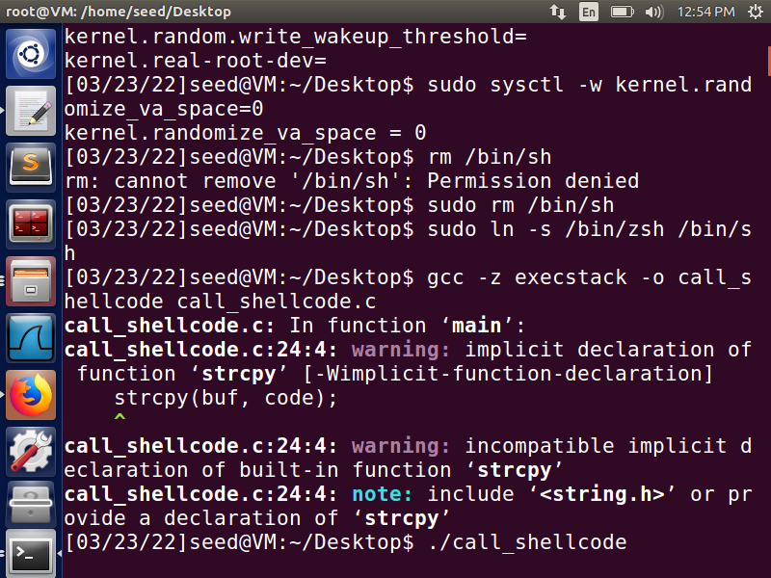

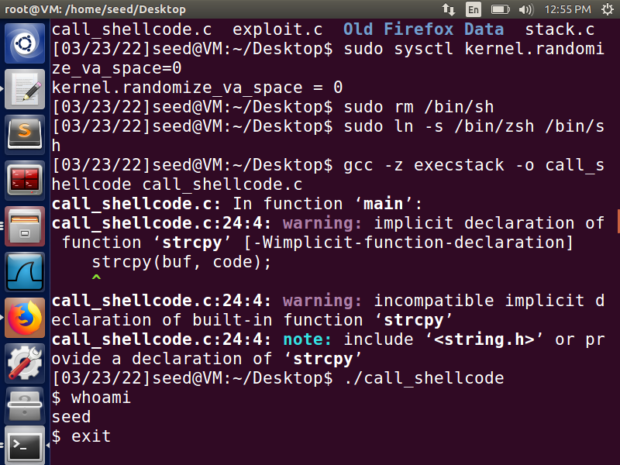

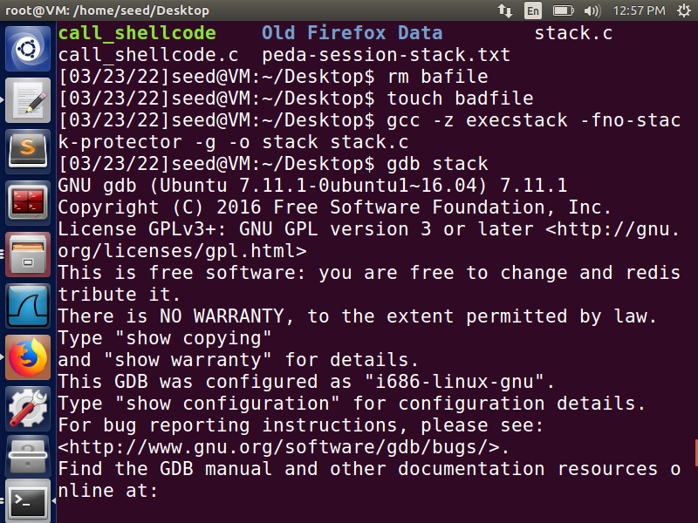

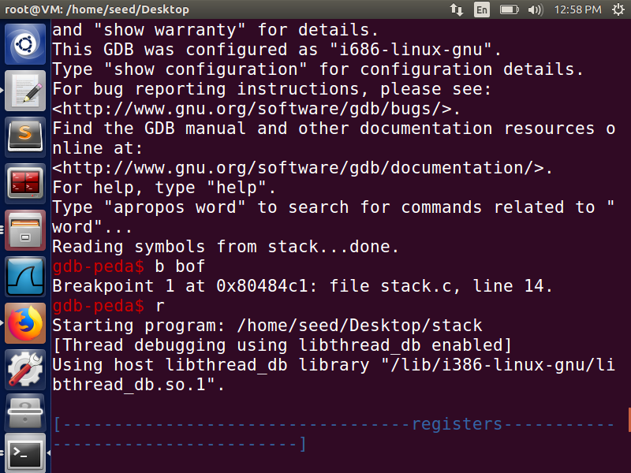

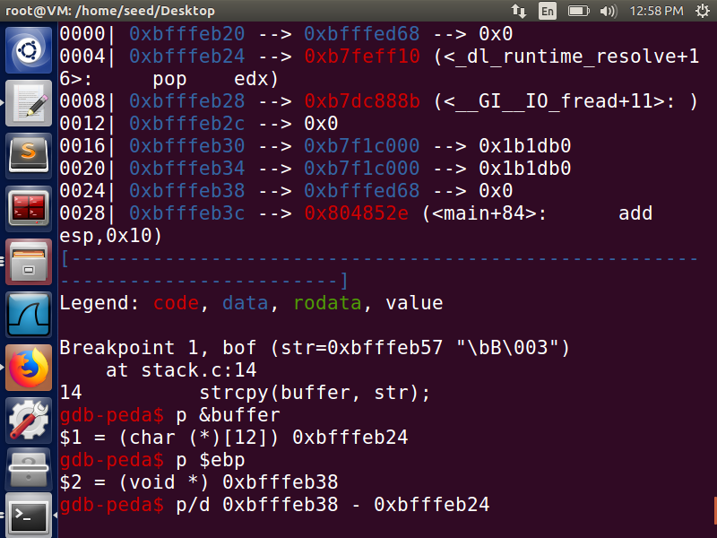

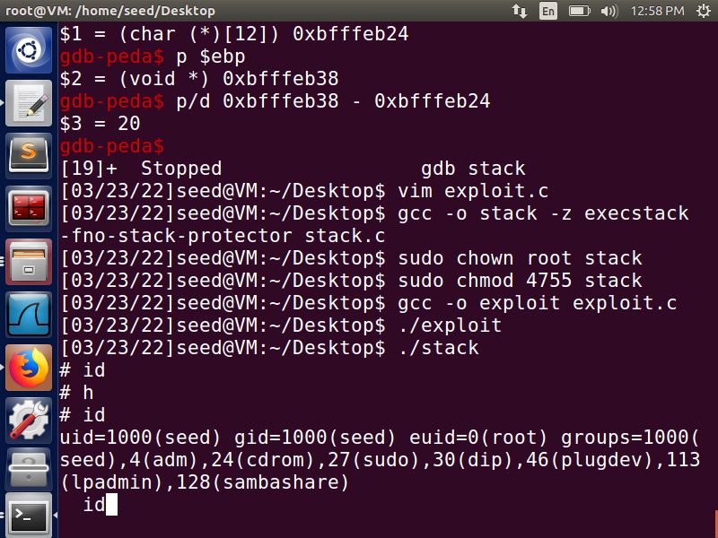

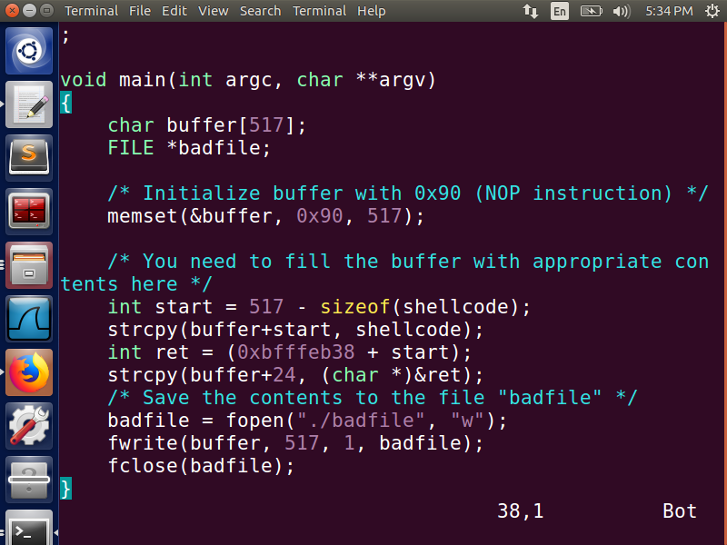

**How I exploited the program.**

* I used gdb debugger to find the return address.
* Inserted a breakpoint at the start of function where buffer overflow attack may occur.
* Printed the address of the start of the buffer.
* Printed the value of ebp register.
* Calculated where the return address is, so I can change the return address and exploit the vulnerability.

**2. Protection in /bin/bash**

* After running the “su” “cd/bin” and linking the bin/sh to the bin/bash when we try to the run the same attack, we are getting the normal seed access and not the root access we were getting in the previous step. 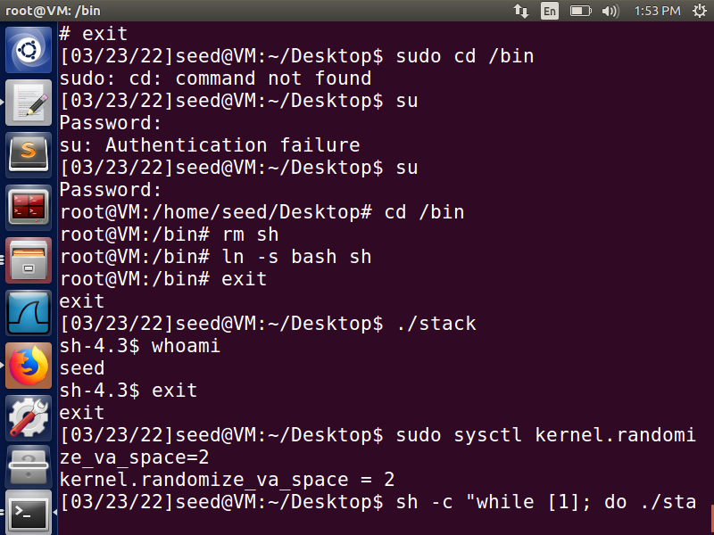
* Extra Credit: As the assignment document we needed to turn the current SETUID process into a real root process, before we invoke the /bin/bash. By modifying the shellcode in the exploit-ec.c we are able to do this. We first set the ebx to zero in the second line. We set eax to 0x5 via Line 1 and 3 and then we execute the system call in Line 4. 0xd5 is setuid()’s system call number.

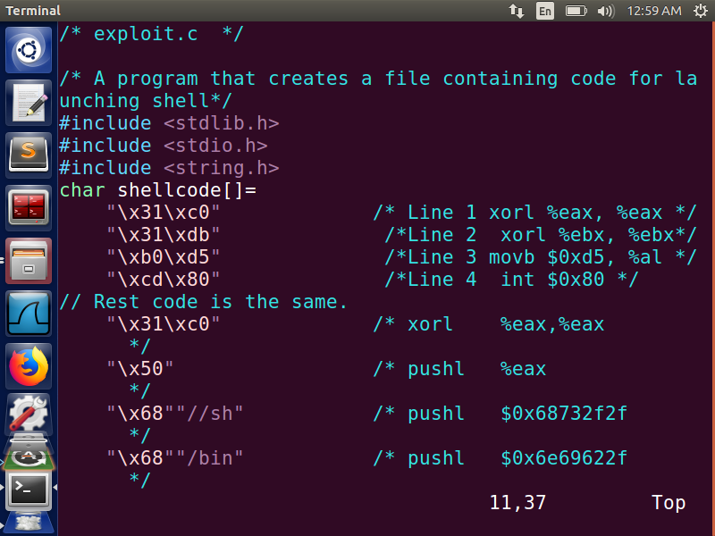

* After making the above changes to the shell code, I am setting the setuid and bypassing the restriction of hash. When I compile the new exploit.c and run it, I am able to get the root access which was desired in the first place.

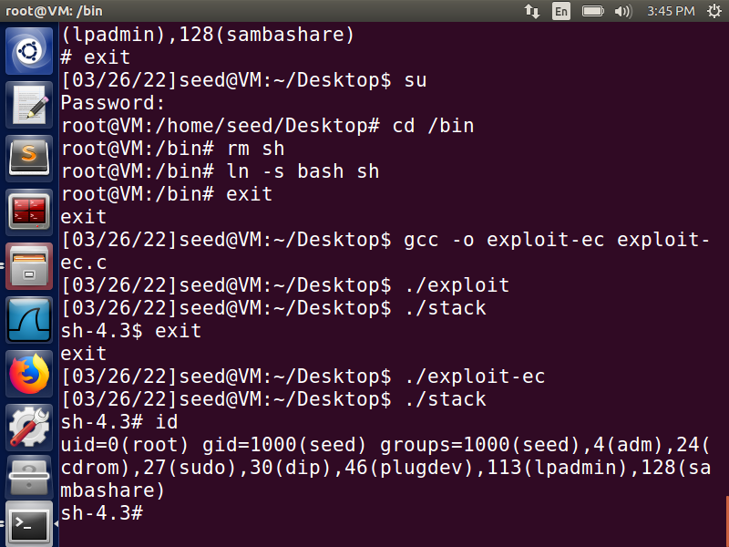

**3. Address Randomization.**

* Earlier in order to perform the buffer overflow attack we had switched off the Linux’s defense mechanism against buffer overflow by turning off the address randomization.
* For this part we activate the address randomization using the command “sudo sysctl -w kernel.randomize_va_space=2”.
* I compiled the stack program using stack guard protection and making the executable of the stack.
* When tried to run for the first time using “./stack”. I got segmentation fault.
* As suggested in the assignment. When I try to the run this in an infinite loop , I keep getting segmentation faults. But I think that with patience and letting the program run for a few minutes, I might be able to get the root access.

**4) Stack guard.**

* We now compile the program with the Stack Guard protection.
* We do this using the command “gcc -o stack execstack -z stack.c”
* When we run the excutable ./stack the system recognizes the buffer overflow attack and gives us the smashing detected segmentation fault and aborts the program.

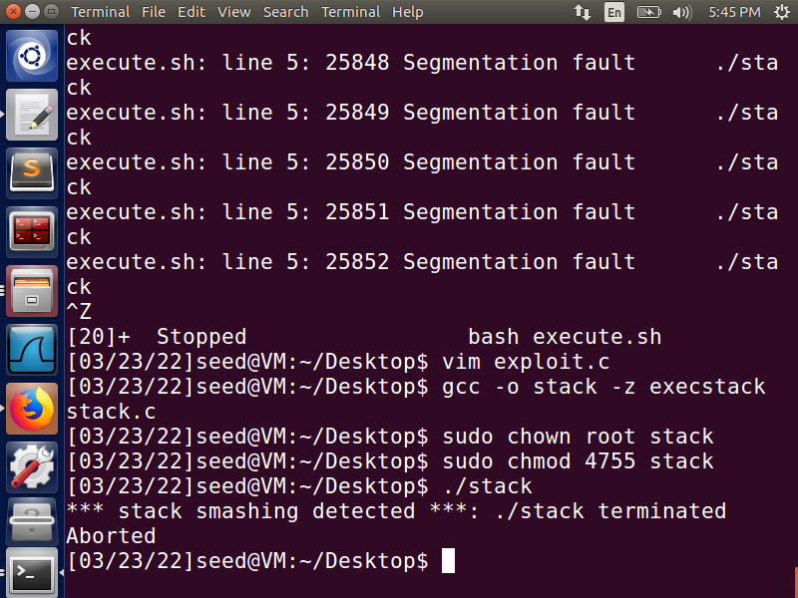

* Extra Credit Part: We know the reason why we are getting the smashing detected because to protect from such attacks, Linux and ubuntu has a mechanism to prevent this. They try to maintain a canary value which is a value placed right after the stack pointer on the stack and this value is validated if the inserted value remains the same right before the function returns to its caller, otherwise we get the above error message.
* I tried to observe this canary value by disassembling the ./stack file first when it is executed with the -fno-stack-protector which is compiled as the ./stack and then without the stack protector flag which is compiled as ./stack2.
* I run the command “objdump -M intel -D stack | grep -A20 main > stack.txt” and similar for stack2 which yields the stack2.txt.
* By comparing the two codes, to find the differences between two files and one thing I notice that we add some extra values at the function prologue and epilogue, this is the canary value. I find that the canary value is %gs:0x14 and now instead of guessing what the value, we know for sure what the canary value is we can make some changes to the shellcode to store this value in some register and then reload this canary value back into the desired register before verifying this value.
* Since we just overwrite the value with the actual canary value so we make sure that this value always matches and this allows us to carry out our buffer overflow attack without being detected and fool the stack guard.
* I was not able to come up with the part for how to make changes in the shellcode, although I hope I get some partial credits for this.

